**Lucy Mae U. Dalisay**

**HISTORICAL BACKROUND OF IMMACULATE CONCEPTION BAUAN PARISH**

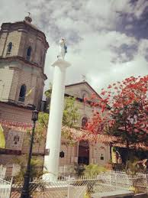The name Bauan comes from a Tagalog word bauang which means “close or concealed and rugged mountain (Noceda-Sanlucar, Vocabulario, 1860, p. 43). It was also said that one day a Spanish official asked a group of local farmers what was the place called. The farmers replied “bawang”, a local term for garlic, believing that what the official wanted to know was what they were planting. This happened when the farmers were planting garlic at the old site of Bauan along Taal Lake. From that time on, the place was known and registered as Bauang, which later became Bauan.

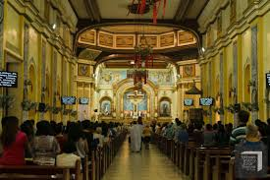On the later part of the 16th century until the middle of the 17th century, Bauan was one of the principal barrios of Taal. Bauan was also called segundo hijo de Taal (second son of Taal) because it was the second visita (a small community which has a chapel but without a resident priest from the town proper) of Taal from 1590 to 1596 (the first visita was Balayan). On May 17, 1590, the Augustinian friars of Taal had chosen Fr. Diego de Avila as the priest-in-charge of the natives of Bauan.  On May 12, 1596, Bauan became a parish with Fr. Ildefonso Bernal as its first parish priest. The parish of Bauan was the fifth parish established in the province of Batangas, which was then under the Archdiocese of Manila. (The first four were the parishes of Taal, Balayan, Batangan (now, Batangas), and Tanauan which were established in 1572, 1579, 1581, and 1584, respectively. The parish of Lipa, established in 1605, became the sixth.) Later in 1641, Bauan parish was placed under the guidance of the Immaculate Conception and hence called the Immaculate Conception Parish, although since 1596, the patron of the parish was the Holy Cross of Bauan or the Mahal na Poong Sta. Cruz.

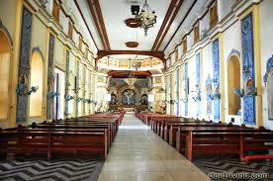The original site of the old Bauan with a church and a convent was a place called Tambo, along Bonbon Lake (now, Taal Lake) and near the foot of Mt. Macolot. This was from 1590 to 1662. From Tambo, the old Bauan was relocated thrice.  The first was to Durungao in 1662 under Fr. Jose Rodriguez and Governadorcillo Josep Cabral. The people stayed there until 1671. A church and a convent made of stone was built there in 1667. The second was to the western part of Bauan beside sitio Sinala which was then called Duclap, named after a plant with many thorns. This was in 1671 under Fr. Nicolas de Rivera and Governadorcillo Juan Manigbas. They stayed there until 1690. In 1689, a church, a convent, a school, and a cotta or fort were built there. The third and last relocation was made in 1690 under Fr. Simon Martinez and Governadorcillo Lucas Mangubat. The location, which was the fourth and the present site of Bauan, was called Tulusan. This site was near the sea and not so far from Punta de Asufre (now, Cazdor Pt.) and Isla de Maricaban (Maricaban Island).

There, in 1695-1697, a church with a convent was built under Fr. Ignacio Mercado and in 1700-1710, another one was built under Fr. Blas Vidal. The present church of Bauan was built in 1762 with the supervision of Don Juan Bandino and under Fr. Jose Victoria, the same priest who had started the built-up of the historic Taal church.

In 1775, a fort in Aplaya was built under Fr. Miguel Brañas to prevent the town from the attacks of Moros or Muslims. This fort was ordered to be broken down in 1845 by Fr. Manuel de Arco.

Earlier in 1653, Bauan was separated from Taal and constituted as a town. The main reason for the separation was the distance between the two places and the growing populace of Bauan. The people of Bauan, led by Fernando Mangobos, who later became the first governadorcillo, made a petition for separation which was approved by the Spanish authorities. But then in 1660, Bauan was again placed under Taal due to lack of taxes collected in the town. In 1672, Bauan began to keep its own registry of births and deaths.

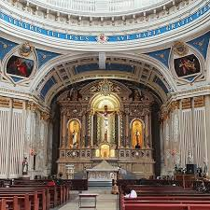

The first center of population of the town of Bauan was a place along Bonbon Lake called Calumala (now, a part of Sta. Teresita, Batangas). When Taal Volcano erupted in 1754, Bauan inhabitants moved to a sitio called Gintuan, located in the western side of a hill we now call Durungao. After staying there for three years, the people moved to another sitio called Taboc due to lack of water in sitio Gintuan. Sitio Taboc had a river with the same name. But after six months, the people again transferred to a wider and more fertile area called sitio Tulusan, which was near the sea and had a spring called Pansol. This was the present site of Bauan poblacion or town proper. Tulusan was so called because at that time there were plenty of tulos (stake) for the mam-inan (mam-in is a plant used by old folks in their nganga, a habit to strengthen teeth) owned by Agustin Madlangpilac, who later donated a portion of his property to the municipal government.